Handprint Pirate Craft for Kids (Card Idea)
Have your kids make this adorable handprint pirate craft! It’s fun for them to make and the card ideas are endless! For example, you can say “You’re GRRReat Mom!” for a Mother’s Day card or switch it to “dad” for a father’s day card! Arrgh!
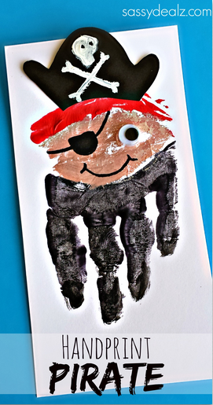

You will need red/black/white/skin colored paint, a black sharpie, 1 googly eye, and white/black paper.
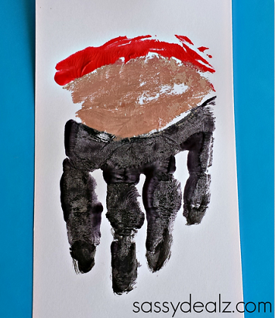
Start by painting your child’s fingers with black paint, excluding the thumb. After that use the skin colored paint for the middle and do a line of red above that. Have them press hard down onto a piece of white paper.

While the paint dries, cut out a pirate hat with black paper and paint white bones on it. Glue on the googly eye and draw the pirate’s eye patch!
